Chapter 11, Problem 29.

Calculate the effective value of the current waveform in Fig. 11.60 and the average power delivered to a 12-Ω resistor when the current runs through the resistor.

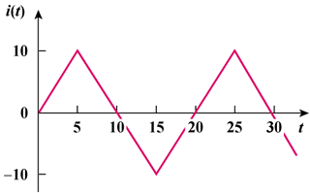
–30
30

Figure 11.60
For Prob. 11.29.

